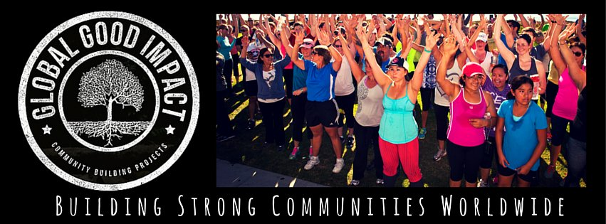
Administrative & Special Projects Assistant
Job Description

This part time position supports Global Good Impact Project Managers and the Director with administrative functions of numerous community building projects and programs. Position is 5-10 hours per week with the ability to grow and cross train in other positions if so desired and add hours as the company grows.

Global Good Impact – Building Strong Communities Worldwide

Global Good Impact envisions a world where individuals have the skills, confidence and network to tackle the world’s most significant challenges. We give people tools to help people do just that - affect the change in their communities that they want to tackle. Global Good Impact offers educational workshops and trainings, networking events and help people and organizations initiate the important community projects they’ve wanting to do and make a difference, so they are no longer talking about it, they are doing it! Global Good Impact also has staff that serve as project managers to assist organizations to put on large-scale community building projects to build community around their causes. http://www.globalgoodimpact.com

Duties include:

- Outreach and follow up communications to existing and potential clients and program participants
- Assist to coordinate and set up projects, programs and events.
- Make occasional website updates on a wordpress platform
- Set up meetings for company staff, attend meetings and take notes where appropriate
- Assist to manage relationships with partners, sponsors and program participants
- Write and edit various communication pieces to potentially include press releases, e-newsletters, social media campaigns
- Support the growth of programs and support the company staff in other duties as required
- Participate in meetings on behalf of company and report back to appropriate staff
- Assist in collecting information and resources to assist in growing programs

Desired Skills & Experience

- Excellent communications skills, both written and verbally
- Ability to multi-task and juggle diverse responsibilities
- Ability to work independently (virtually) and check in / report out weekly for staff meetings and individually as needed in Santa Barbara
- Experience using google drive, docs and sheets
- Experience with Microsoft programs such as excel, word, powerpoint
- Experience in customer relations
- Experience working with diverse sections of the community ie: nonprofit, social business, tech, government
- Experience managing small and large scale events or community projects
- High school graduate, college graduate preferred though not required, must be 21 to attend some events

Desired Personal characteristics:

- Sense of humor and an fun outgoing attitude
- Extreme attention to detail
- Interest in supporting change-makers locally and around the world
- Ability to work as part of a team
- Ability to take direction, prioritize tasks and meet deadlines
- Excellent references
- Interest in being part of a growing company
Benefits:
- Opportunity to learn about, support and spotlight innovative projects and change-makers around the world
- Ability to be on the leading edge of community building work and work on high profile projects locally.
- Opportunity for growth and cross training in other positions such as Workshop Trainer, Project Manager and Sales positions.
- Extraordinary networking opportunities
Compensation:
Wage: $12/hour, 5 – 10 hours a week
Application Instructions:
Please send cover letter and resume to globalgoodimpact@gmail.com. Position open until filled. For more information on the company visit http://www.globalgoodimpact.com

